 



**eProject Document**

Tunga Restaurant

|  |  |
| --- | --- |
| **Group 1** | |
| **Members** | Nguyen Hoang Nam - B9036  Tran Van Tung – B9099  Bui Cong Tien – B9074 |
| **Batch** | C2010G2 |
| **Semester** | III |

# **Hardware and Software Requirements**

### Minimum Hardware Requirements

* CPU: Pentium IV 2.00 GHz.
* RAM: 512 MB.
* Hard Disk: 5 GB.
* OS: Windows 2000/XP/Server 2003.
* Internet Explorer 7.0 or FireFox 12.0
* Internet information services (IIS) 5.1 or higher.

### Recommended Hardware Requirements

* CPU: Duo Core 2.00 GHz or higher.
* RAM: 2 Gb or higher.
* Hard Disk: 80 GB or higher.
* OS: Windows 10.

### Software Requirements

* Web Server: Internet Information Services (IIS 7.0) or later
* FireFox 12.0.
* SQL Server
* Visual Studio 2017

# **Install Application “EprojectSemIII”.**

## Setting up database

1. **Change password**
   * We using Microsoft Sql Server 2017, so the first thing need to do is open it

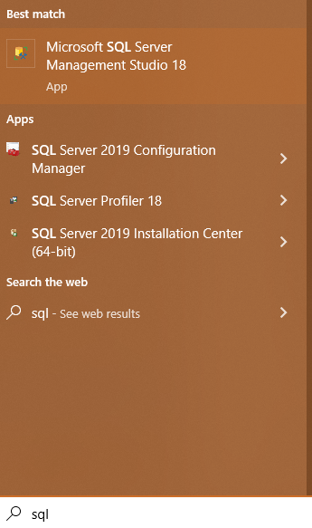

* + Secondly, choose your password with “sa” account, after that copy it and open project named “EProjectSemIII” by Visual Studio 2017, and open file appsetting.json and change password what you copied to password in this file.

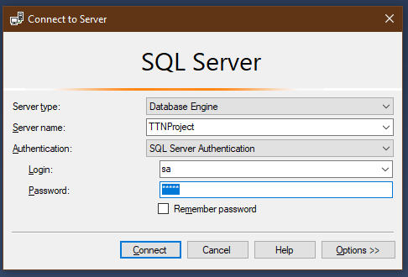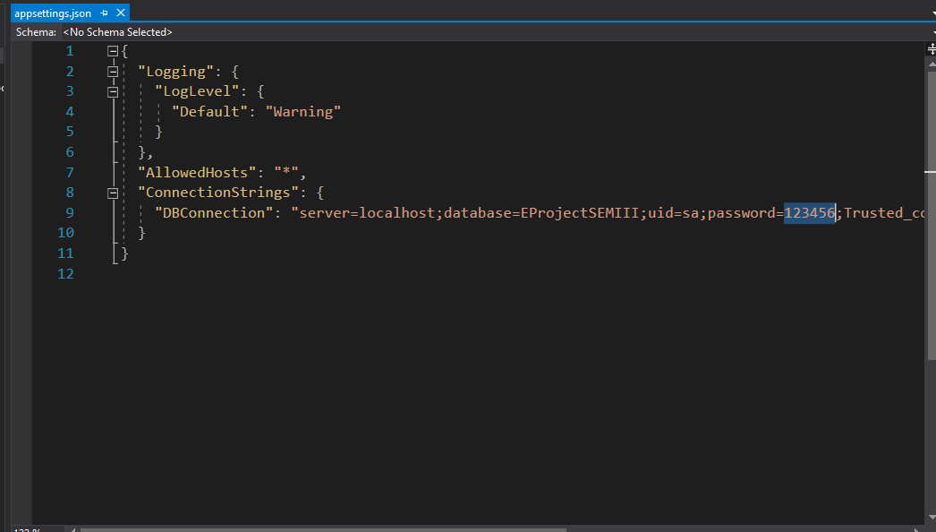

### Migrate database

* Open solution using Visual Studio 2017
* Open Package Manager Console
* Run “Add-Migration” command
* Enter migration’s name. For example: ver1
* Run “Update-Database” command

### Insert necessary data

### 

* Open “Solution” Folder, and choose “EProjectSemIII”, find “BaseData” folder and choose “BaseData.sql”, open it with Microsoft Sql Server, Login and run query

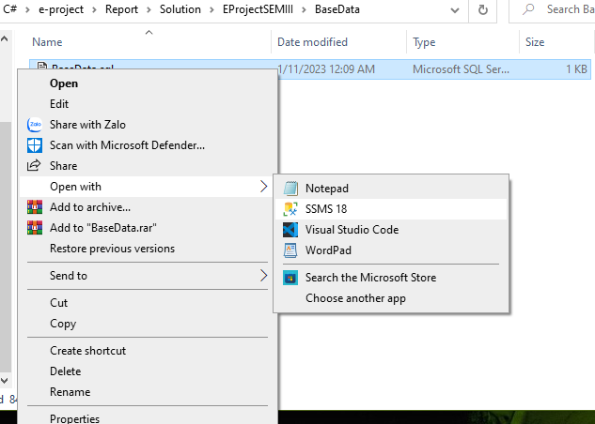

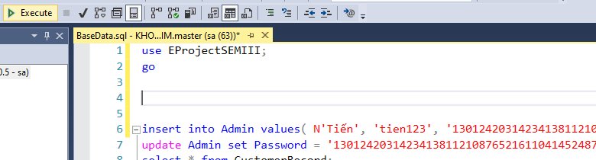

* After run command successful, reopen “Visual Studio 2017” and run project.

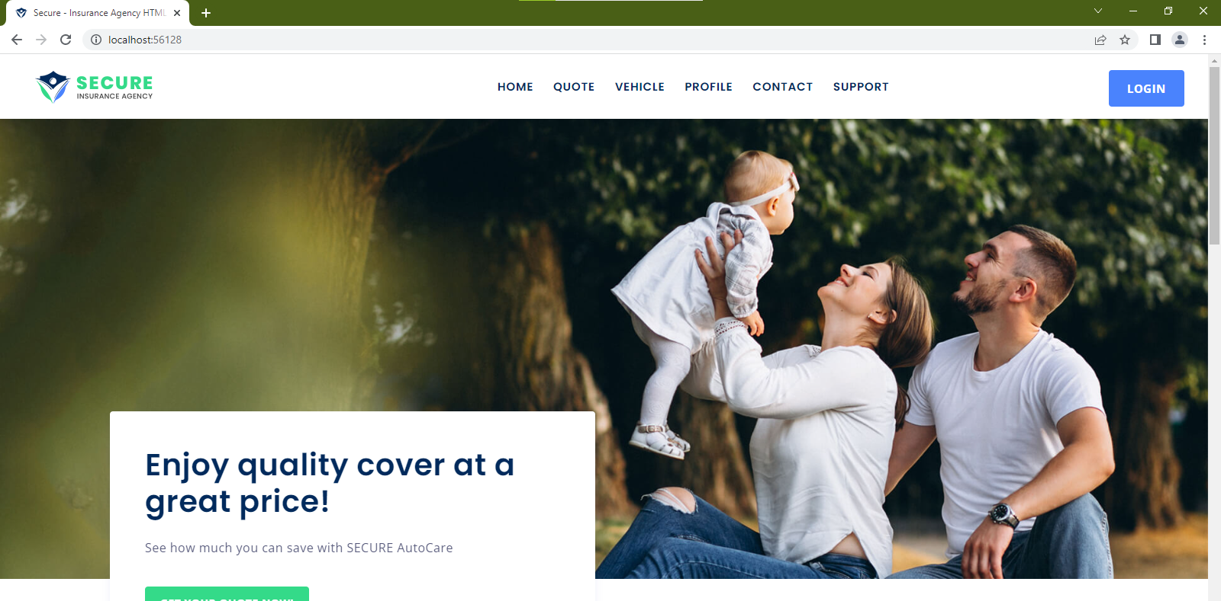

* After that type /admins in url, page will redirect you to login page, enter username and password below to login
  + Username: admin
  + Password: 123456
* After login success you will be send to dashboard page

*This step is important as it will insert important data to database, you can disable this account via account manager later

## Using Manager to add data to application

### First, after login success, you’ll go to dashboard page, this page will show revenue statistics

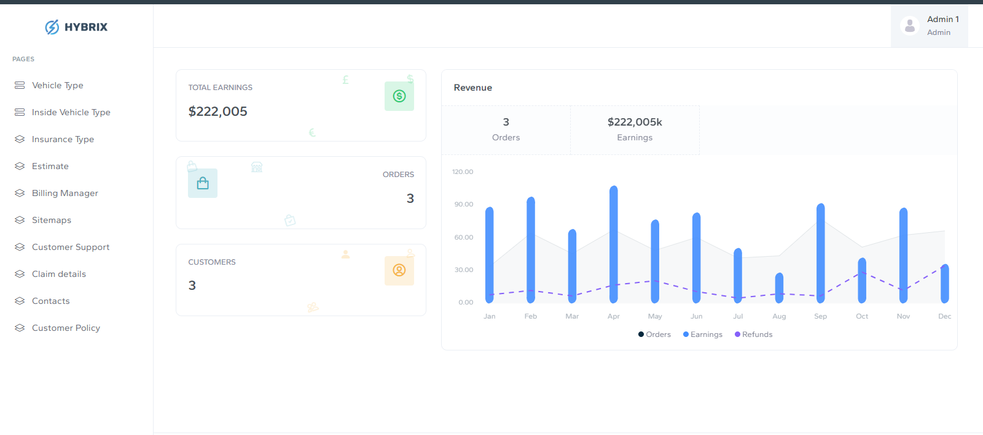

### Vehicle Type: This page will help you manage vehicle type for system.

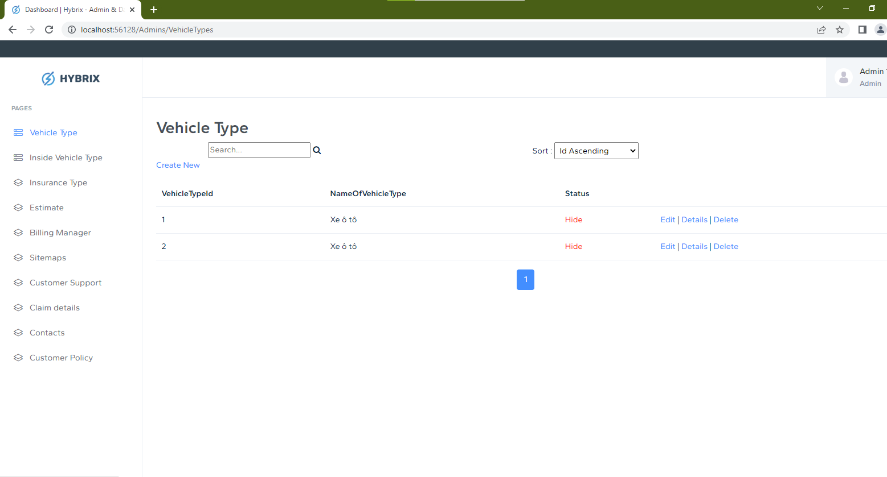

#### Inside Vehicle Type: This page will help you manage inside vehicle type for system.

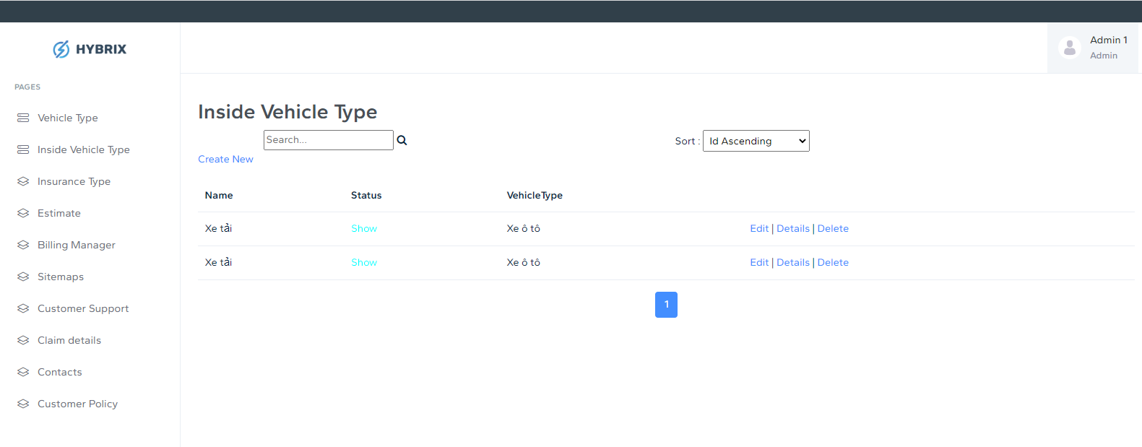

### Insurance Type; This page will help you manage insurance for system.

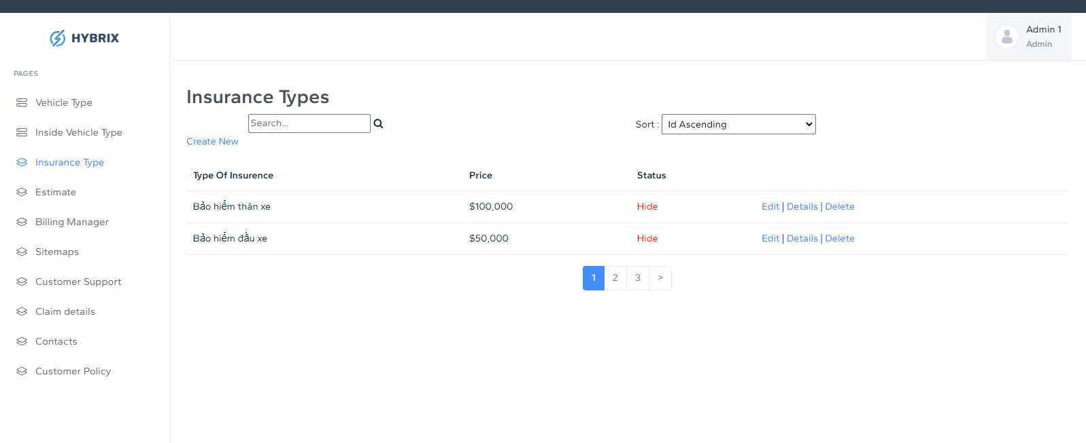

### Estimate: This page will help you give estimate and relevant insurance for each vehicle information of customer.

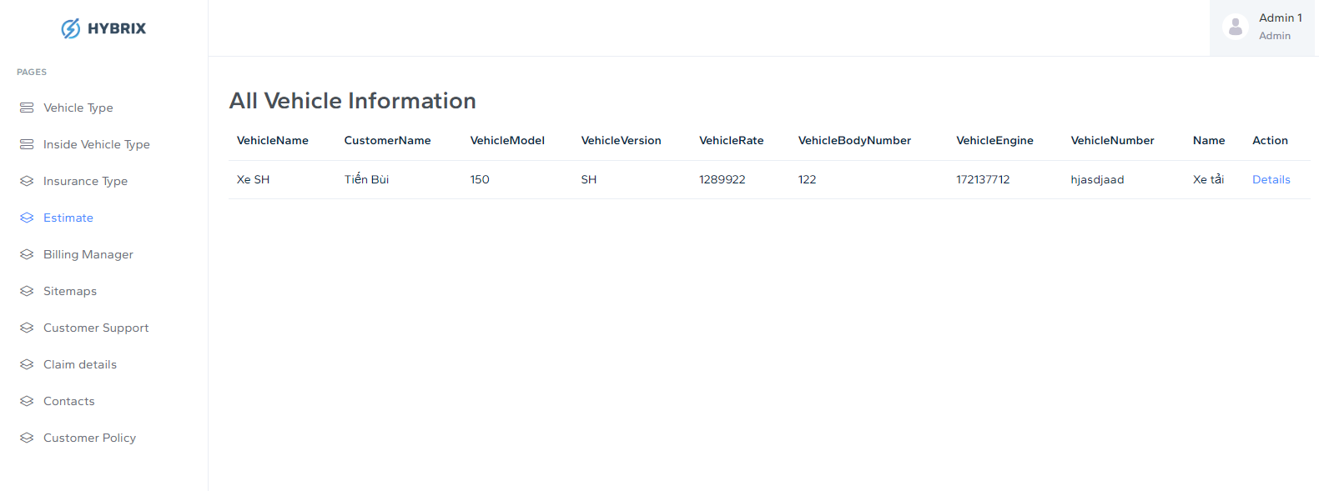

### D2. When click Detail, you can add more estimate and relevant for customer vehicle’s information

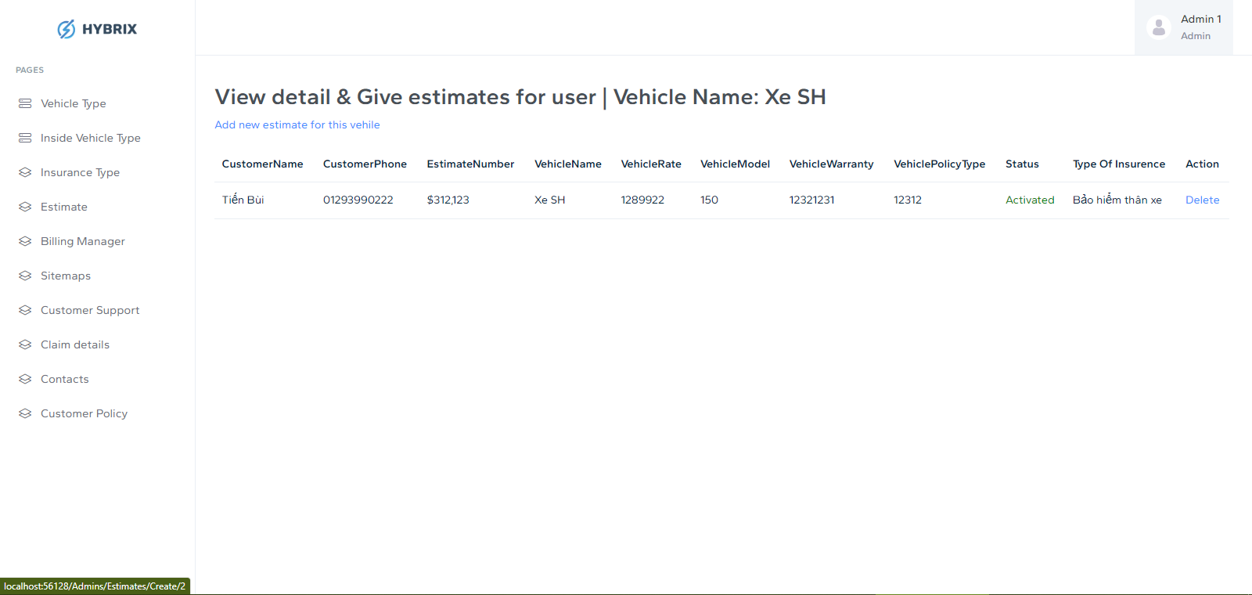

### Bill Manager: Help you manage bill and activate insurance for customer when they paid.

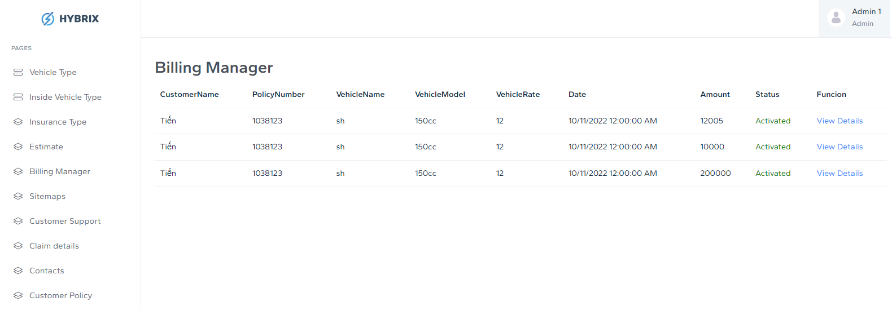

1. **Sitemaps: Help you manage sitemap for your site.** 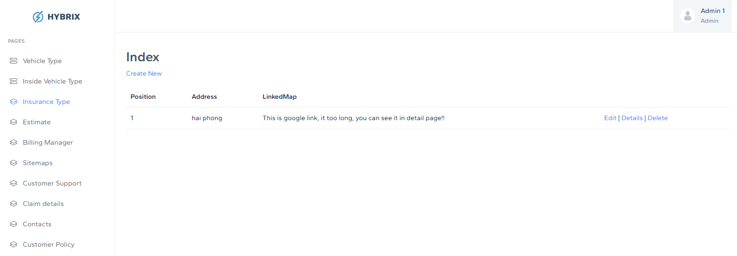
2. **Customer Support: Help you manage Faq’s for Client page** 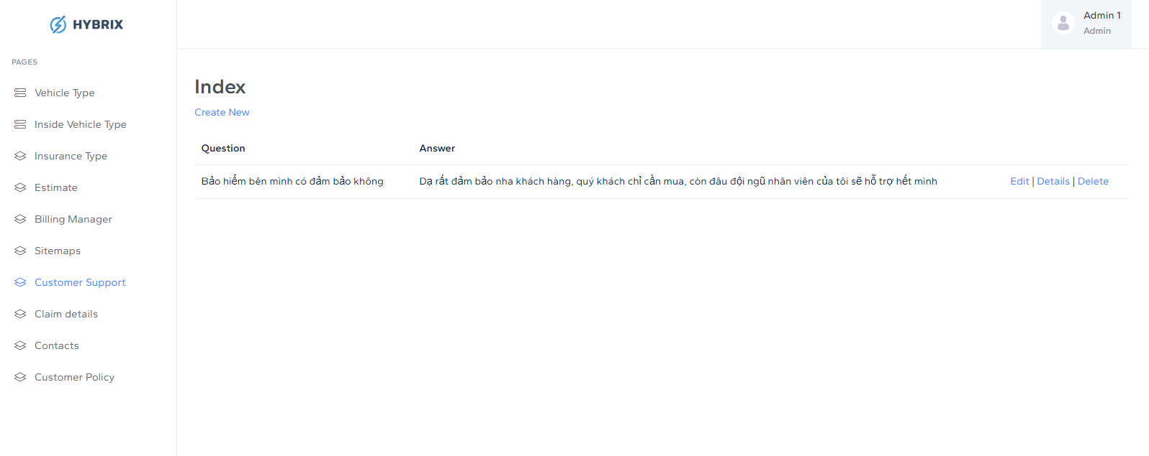
3. **Claim Detail: Help you manage Claim detail of customer** 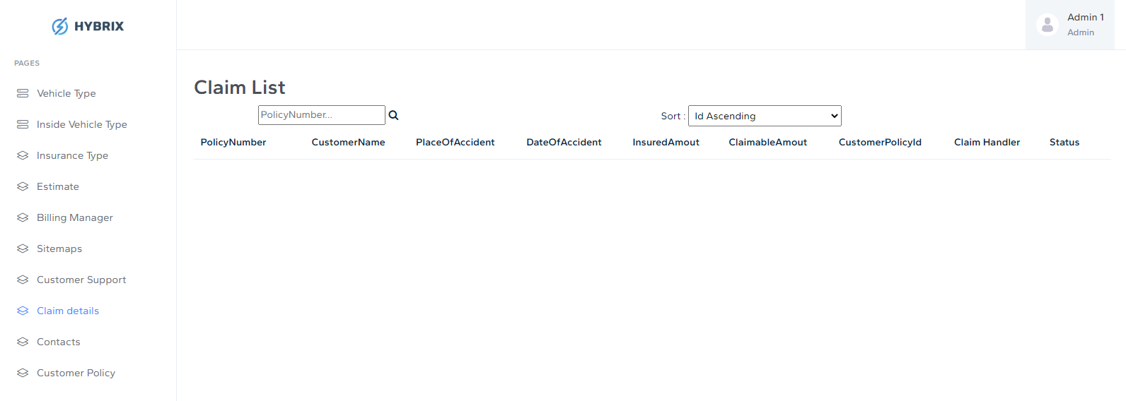
4. **Contacts: Manage contact for site** 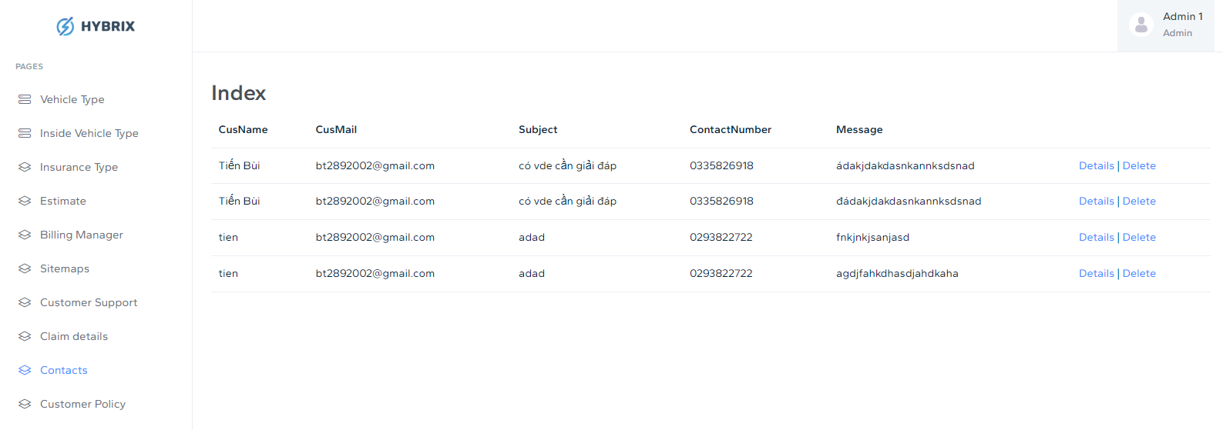
5. **Customer Policy: Active and storage insurance’s information for customer** 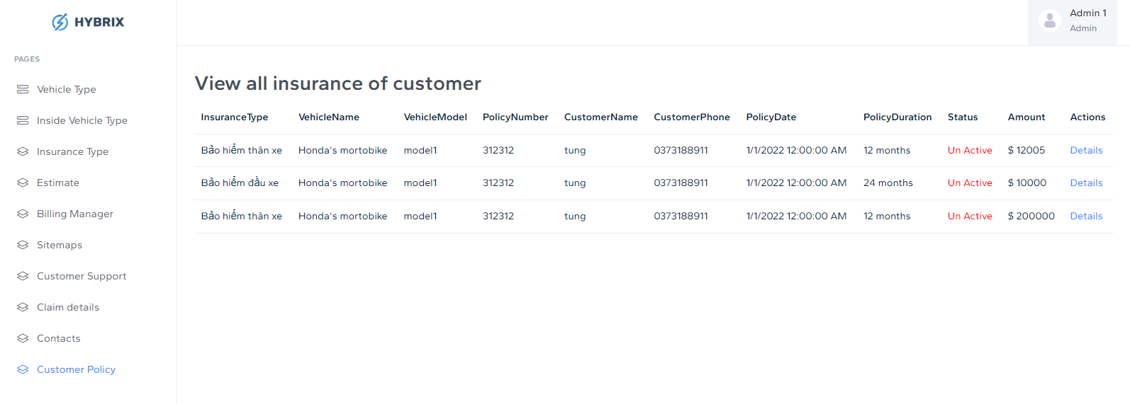

# **Customer usage**

## Home page



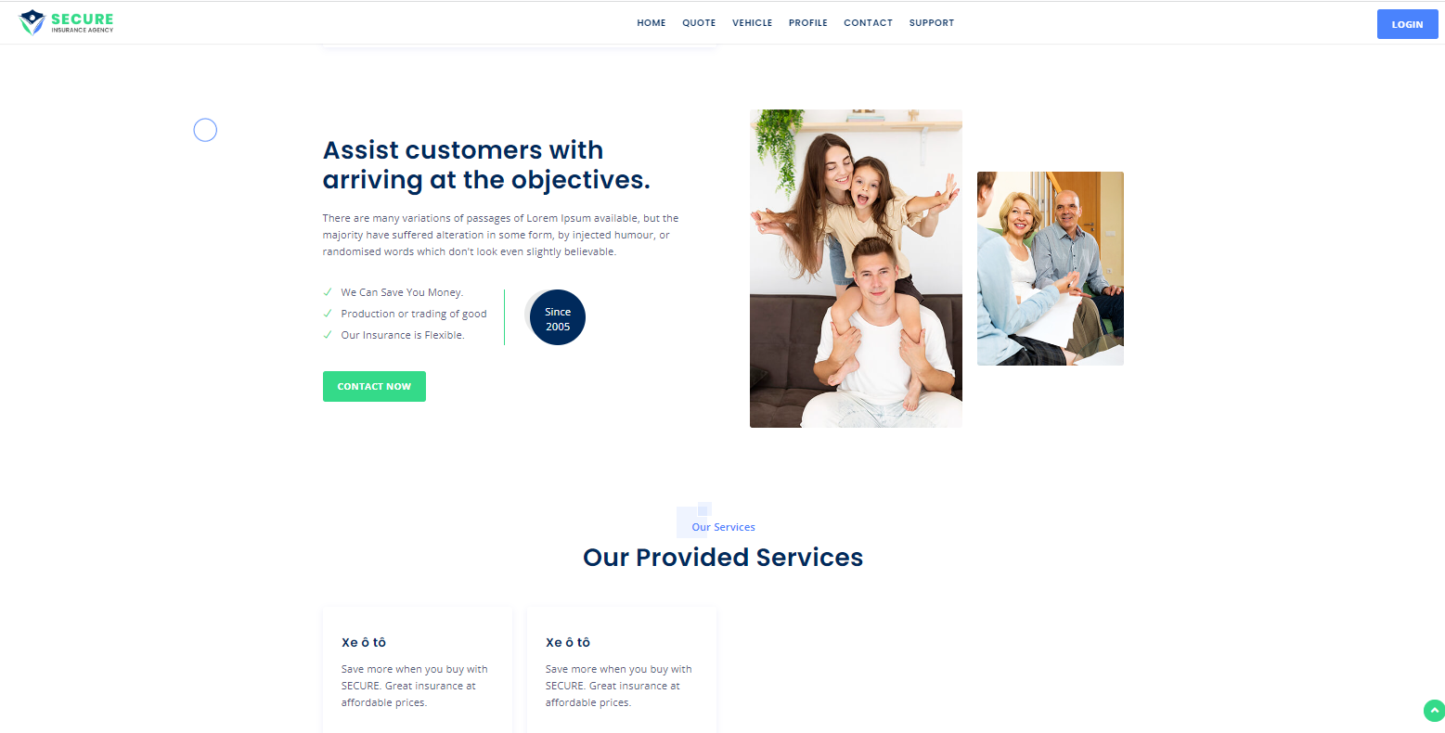

## Quote Page & Vehicle Page:

**2.1** . After login, you can fill your vehicle information, choose type of vehicle, when done, you will be redirect into your vehicle information page 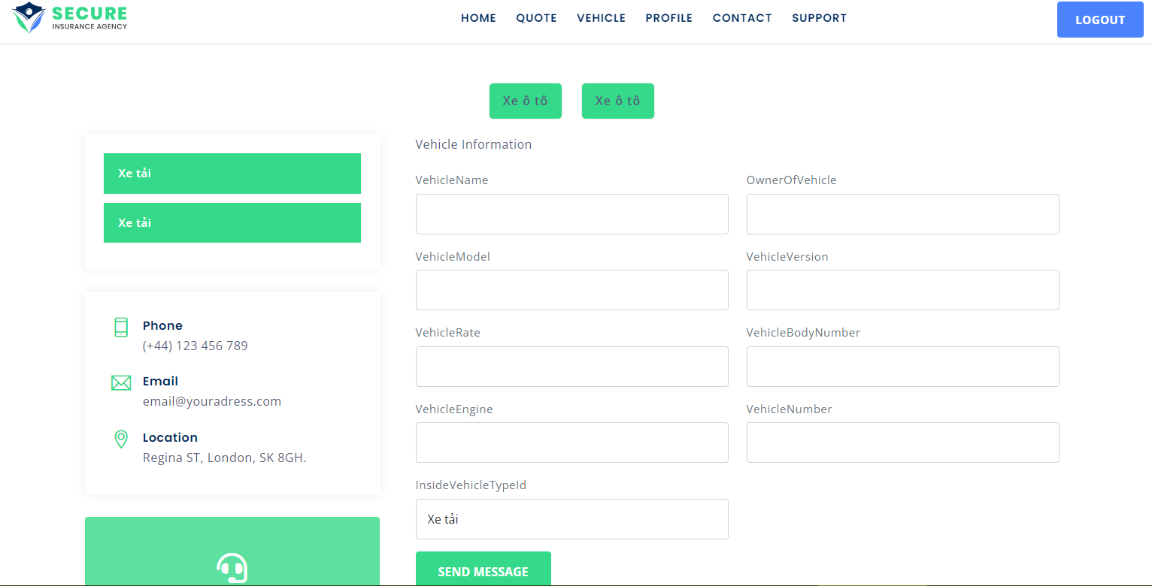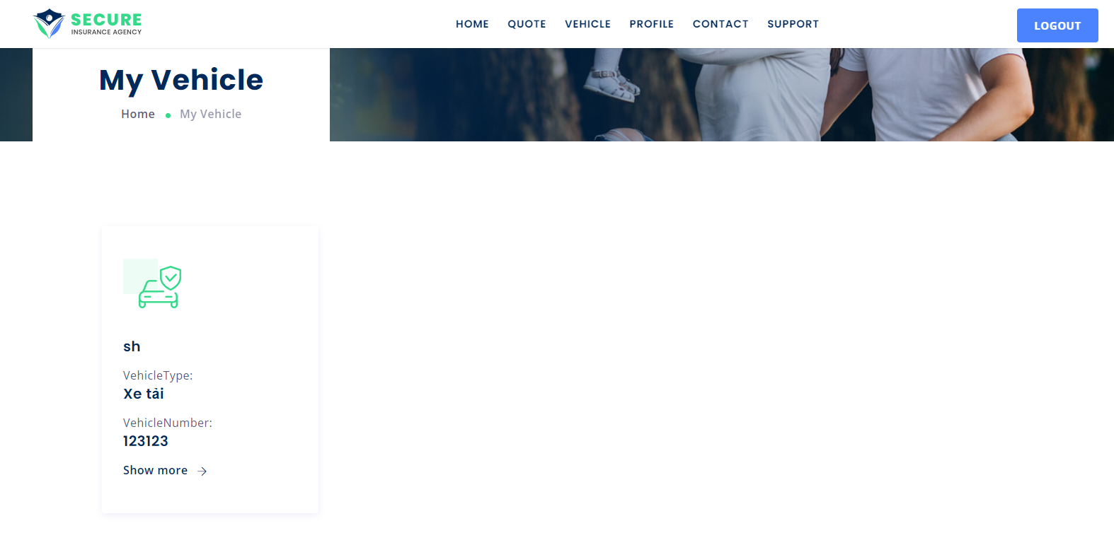

**2.2. When click “Readmore”, you will see two option, “Estimate” – View supported insurance; “Insurance”- View insurances for your vehicle.**

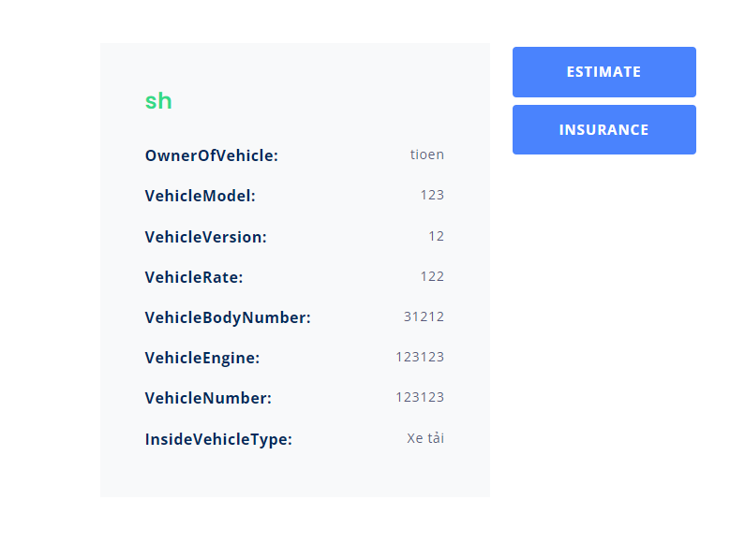

**When click “estimate”, you can buy this insurance for your vehicle.**

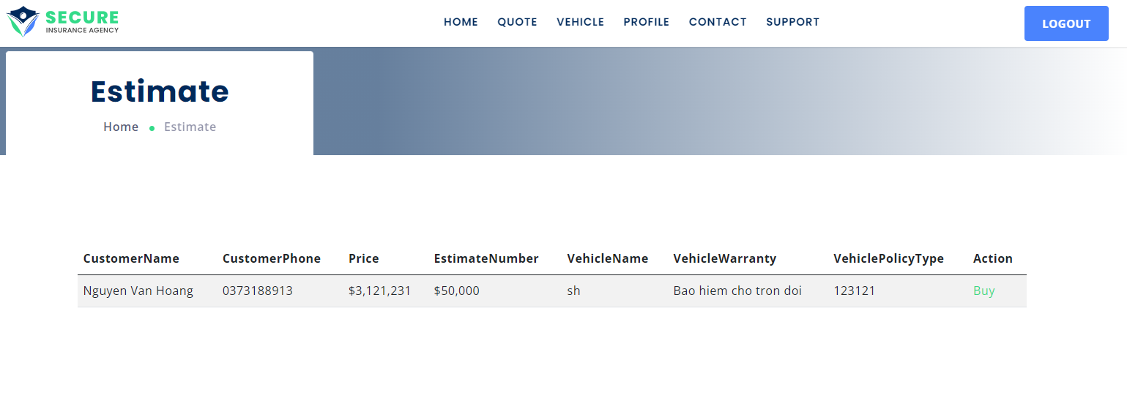

When click “Insurance”, you can see a list insurance what you bought. 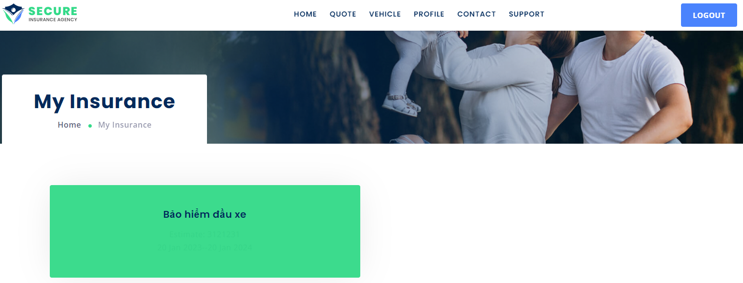

**When click into your insurance. You can request and view claim detail**

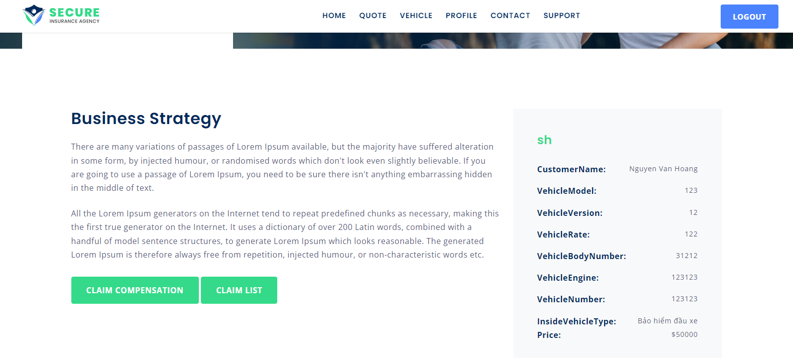

## Profile: You can update your profile and password.

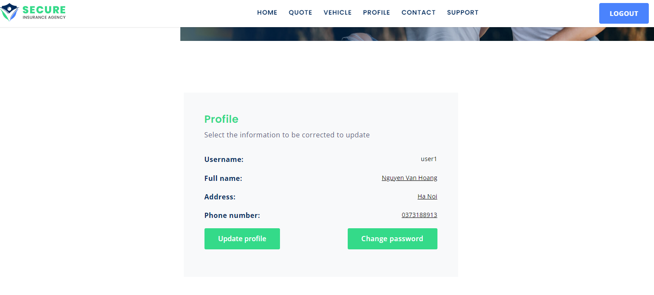

## Contact

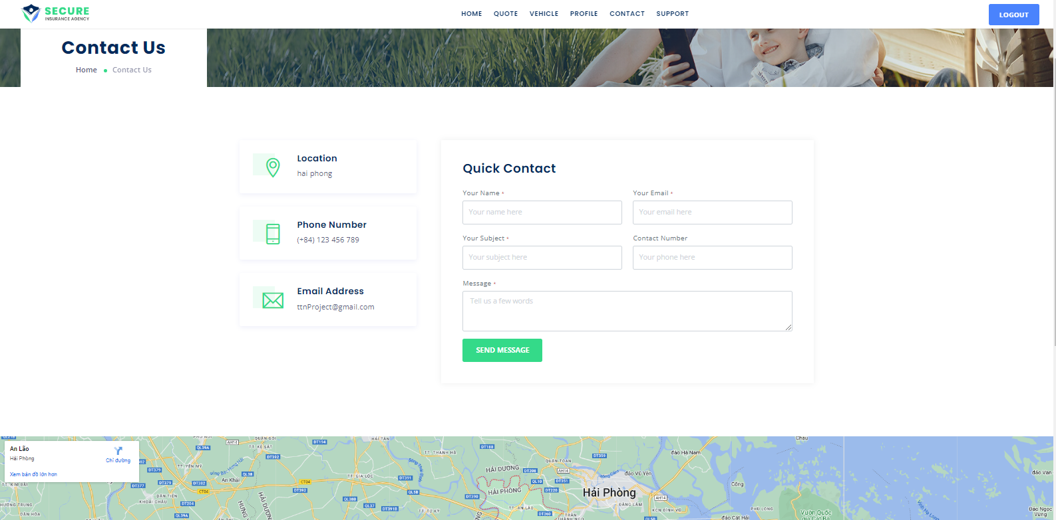

## Support

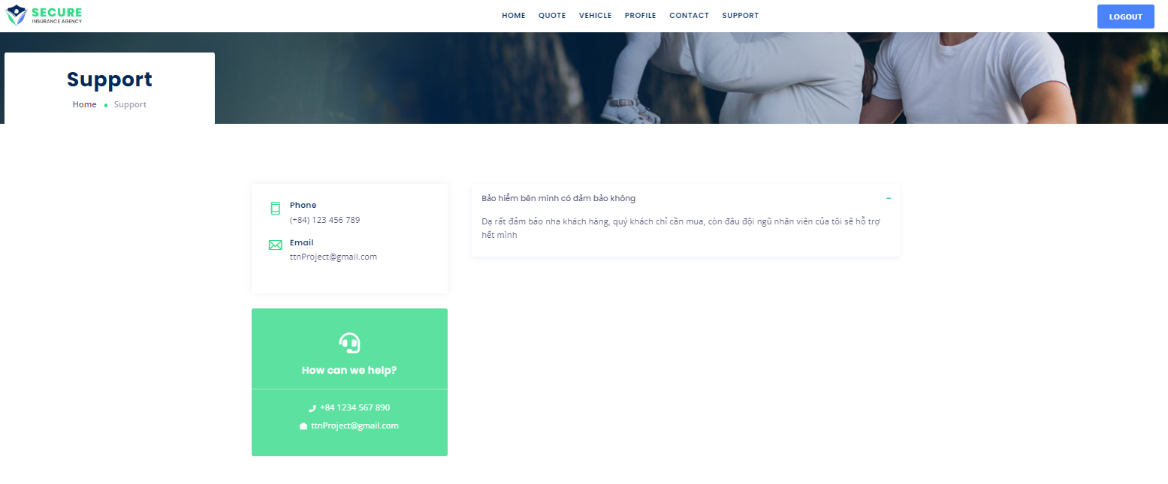

## 

**THE END**